Braille Me User Guide V 1.8
Last updated on: 12/5/2018
Inceptor Technologies Pvt. Ltd. (Innovision)
Firmware version: M02.02S01.05H09.10
Contents
1. Introduction 3
1.1 Features of Braille Me 4
1.2 Document conventions 4
1.3 Inside the box 5
2. Orientation 5
3. Powering the device 9
3.1. Powering On/Off 9
3.2. Charging 9
4. Menu system 10
4.1. Panning Keys 10
4.2. Edit box 10
4.3. Cursor 11
4.3.1. Mode 1 11
4.3.2. Mode 2 11
4.4. Word wrap 12
5. File manager 12
5.1. Browse 12
5.1.1. Supported Files 12
5.2. Search 12
5.3. Read, edit, Rename and Delete 13
5.3.1. Read 13
5.3.2. Edit 13
5.3.3. Rename 13
5.3.4. Delete 13
5.4. New File 14
5.5. Editor 14
5.6. Braille Translation in Braille Me 16
6. Bluetooth 17
6.1. Pair new device 17
6.2. Connecting to a smartphone 18
6.3. Using with BrailleBack 18
6.4. Using with VoiceOver 19
6.5. Using with Braille Me app 19
7. USB 20
7.1 Connecting with NVDA 20
7.2 Connecting with VoiceOver 20
7.3 Connecting as mass storage 20
8. Settings 21
8.1 Language setting 21
8.2 Factory reset 21
8.3 Date and time 21
8.4 Braille Test 21
8.5 Software version 21
8.6 Auto scroll time 22
8.7 Standby time 22
9. Battery level 22
10. System Shutdown 22
11. List of all commands 22
11.1. Global commands for Braille Me 22
11.2. Braille Back commands 24
11.3. NVDA commands 25
11.4 Voiceover commands 26
12. List of system notifications and errors 27
13. Firmware upgrade 29
14. Battery replacement 30
15. Specifications 31
16. Installing NVDA Add-on and driver 32
17. FAQs 33
17.1. Prospective User 33
17.2. First time user 34
17.3. Existing User 35
18. Appendices 36
18.1. Warranty information 36

- Introduction
Braille Me is a sleek, portable and lightweight smart braille display. It is a competent device specially designed for visually impaired students and professionals.
With its revolutionary Braille cell technology, Braille Me is highly compact and cost-effective. At Innovision, we understand the challenges faced daily by students and professionals, and keeping their recommendations in mind, we have built Braille Me.
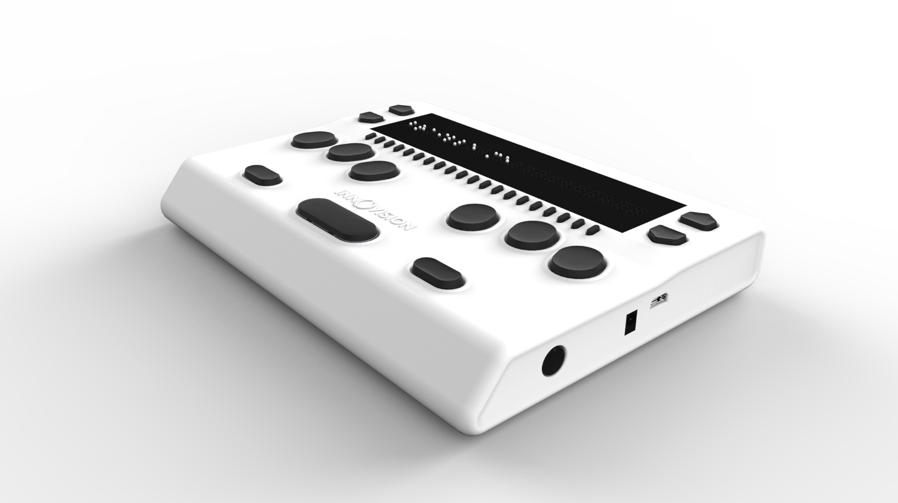
Image of Braille Me in isometric view
Braille Me is a compact smart braille display with the following capabilities:
• 20 braille cells representing any six-dot braille code, in any language.
• Capable of reading the contents of files from an SD card under Stand-Alone mode.
• Connectivity to PCs and mobile devices via Bluetooth and USB
• A basic note-taking feature with internal braille translation

It operates in 2 ways – Standalone reader mode and remote mode.

Standalone reader mode:
In this mode, Braille Me displays the content of files stored on the inserted SD card. Braille Me allows you to browse files, read, edit, rename and delete them. Braille Me has a built-in braille translator to support grade 1 and grade 2 translation and multi-language braille.
Remote mode:
You can connect the device to a computer/ smartphone/ tablet using either Bluetooth or USB. Once connected, you can navigate, read and edit the content present on the connected device through Braille Me seamlessly. You can also read books on your smartphone from Kindle, iBooks, Bookshare, etc.
  - Features of Braille Me

- Six - dot 20 braille cells with paper like feel
- 6 key Perkins style keypad
- Removable battery lasting for 10 hours on continuous usage
- Upto 32 GB storage through captive SD card
- Support for 40+ languages
- Remote connectivity to PCs and Smartphones through Bluetooth and USB
- Notepad with several editing and navigation functions

  - Document conventions
Throughout the document, Braille keys are indicated by numbers. For example, a button corresponding to Dot 1 is indicated by the phrase – Dot 1. If multiple braille keys are required, it is indicated by the numbers separated by a space e.g. Dots 1 5.
When key combinations are used, a plus (+) sign is inserted between the keys e.g., Space + Dot 1. In such case, all the combination keys have to be pressed together.
When any key combination is pressed, note that the command is executed only when all the keys are released, i.e., If a user presses space + dot 2 3 to execute a particular command then until all the keys - space, dot 2 and dot 3 are released the command will remain on the waiting list and as soon as they are released the command will be executed. On a braille keyboard, Space is often used as a modifier to alter the effect of the input keys.
Messages, menu items or errors displayed on the braille display are denoted within quotation marks.
There are 2 types of messages in the software – notifications and errors denoted in the document using quotation marks.
Errors occur when there is a difference in the expected user input or any of the internal systems have failed. Notifications are messages which are intended to inform of any changes to the system.
  - Inside the box
Braille Me comes with peripheral devices which are to be used along with Braille Me.
The box contains the following items:
    - Braille Me
    - Printed User guide
    - Braille User guide (Can be pre-loaded onto the SD card)
    - Standard –A to Micro-B USB cable
    - AC charger
    - 32 GB SD card pre inserted in your Braille Me

- Orientation

To begin exploration of Braille Me, place the device on a flat surface in front of you with the row of braille cells farther away from you and the sloping edge nearer to you. This is the proper operational orientation.
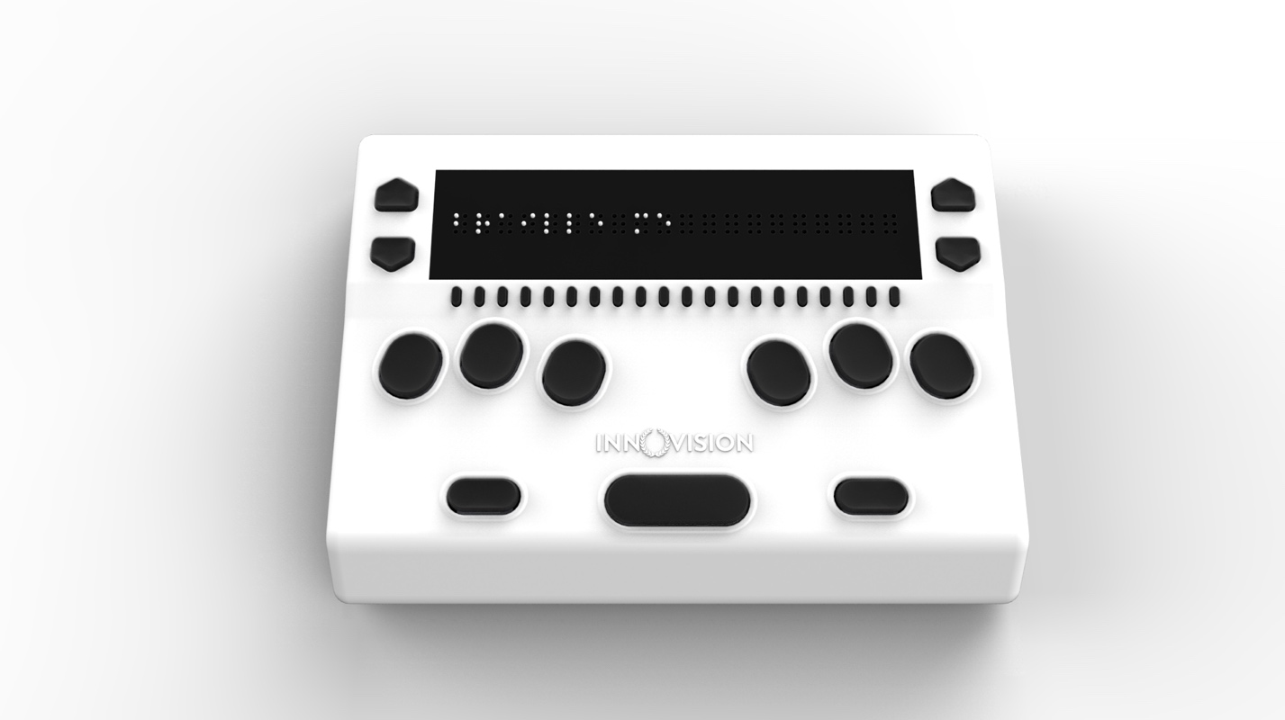
Image of braille Me in top view
Henceforth the guide will refer to this orientation to indicate the position of keys and slots.
On the left face there is a slot for inserting an SD card. When you receive the device, it would already have a 32 GB SD card inserted.
The SD card slot is a standard slot with spring feedback. The SD card is inserted with the card connector fingers facing upward. To release the card, press in and remove your finger to allow the card to pop out.
Drawing of left face of Braille Me

On the right face of the device, you would find a circular button closest to you. This is a toggle button to power On/Off Braille Me. Going forward on the right face we will find two ports – A DC jack for charger and a USB slot.
Drawing of the right face of Braille Me
The DC jack is used to insert the power cord from the charger and is positioned just beside the power button. The USB slot is farthest from you and is used to connect to PCs via a Standard-A to Micro-B USB cable.
Moving on to the top face, you will find a braille display of 20 cells farthest away from you. The texture of the braille display area is smoother compared to the body, and it will have many holes for braille pins. It is accompanied by 20 cursor routing buttons below each cell.
On both the sides of the braille display, we have a couple of keys used for navigation. On the right side we have the panning keys named RightUp and RightDown and on the left side the next item button named LeftDown and previous item button named LeftUp.
As we move towards the lower section from the braille display we have a Perkins style keypad which has 6 keys ergonomically arranged representing the six dots of braille. Dots 3 2 1 on the left and Dots 4 5 6 on the right. It is accompanied by a space bar which is located below these 6 keys in the middle.
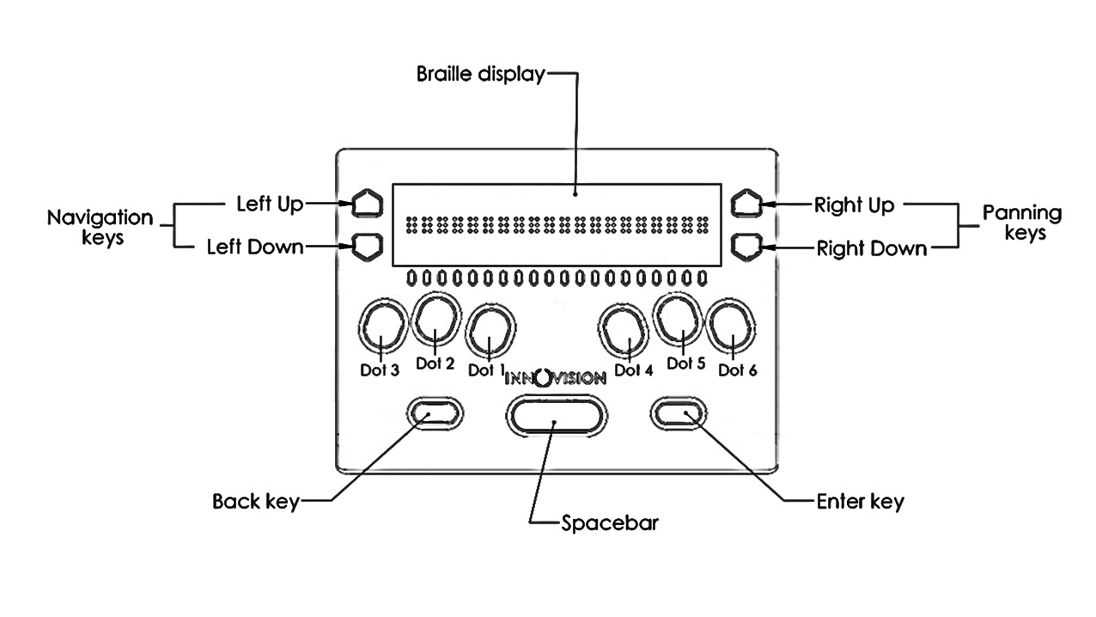
Drawing of top face of Braille Me
On the right side of the space bar we have the enter key and on the left side backspace key. This concludes our top face.
On the bottom of the device a battery compartment is present which is secured with a set of 4 screws.
Drawing of bottom face of Braille Me
Type of button or port | Function | Placing
Display | Braille dots | Upper most part on the top face
Ports | SD card slot | Left face
 | Micro-USB slot | Right face
 | DC jack | Right face
 | Battery compartment | Bottom face
Buttons | Dot 1 to 6 | Six keys in the middle of the top face  Dot 1-2-3 on the left side and Dot 4-5-6 on the right side
 | Space | Lower middle part of Top face
 | Enter | Lower right part of the top face
 | Backspace | Lower left part of the top face
 | 20 Routing keys | Placed below braille display on Top face
 | 2 Panning keys: RightUp and RightDown | On the Right side of braille display
 | 2 Navigation keys: LeftUp and LeftDown | On the Left side of the braille display
 | Power button | Right face

- Powering the device

This section explains how to charge, turn the device on and off, insert the SD card, and enter and exit the menus. Refer to the following sections for additional support.
  - Powering On/Off
To turn on the device just press the power button for 1 sec and instantly the device will boot and you would hear an audio notification – a short beep. Along with this beep, the braille display will get activated, and all dots will toggle up and down. Post this toggling the braille display will show “menu.” As soon as “menu” is displayed, you can start your work. This entire process should take less than four seconds.
There are two ways of shutting down the device. One way is to long press the power button for three seconds and the second is by using the shutdown menu item in the menu. In both cases a long beep is given indicating the shutting down of the device. After the beeps all the dots will move down.
  - Charging
When you receive Braille Me, it may already have some charge; however, we recommend charging it fully before or during first use. You can use the device and charge it at the same time, so this does not hinder your reading time.
When the battery of Braille Me gets to 15% and 7%, you will receive a notification indicating that battery is low. At 2% charge, the device shuts down without notification. During shutting down Braille Me give a long beep, and all the braille dots will move down.
To charge the device, use the AC adapter provided. Insert the power cord into the AC adapter and the circular DC jack into the device. Make sure the AC plug is firmly held in the slot. If the device is powered on, you could check the charging status under battery level in the menu. Also, when in power ON state when the charging is complete a notification will appear indicating battery level full. If the charger is not right or damaged, the device will notify with the message “invalid charger”. Please use only the charger supplied with the device. If the device is powered off, no charging indication will be displayed.
Please note USB charging is not supported and any attempts to do so might damage the device.
If you have charged the device for 1 or more hours, and it doesn't turn on, contact Customer Care at +91-8291406811 or customercare@innovisiontech.co.

- Menu system

An informative yet straightforward menu system is implemented which will help you explore all the functions and settings. At a time only one menu item is displayed. To use the device, Braille Me has a set of universal commands which work throughout the menu system and in its different applications.
Action | Universal command
To go inside/ select a menu item | Enter key
To go 1 step back in the menu hierarchy | Backspace + Space key
Navigate to the next/ previous menu item | (Leftdown/ Leftup)
To Pan left to right | RightUp/ RightDown

Apart from the above-listed commands, you may also need to use the cursor routing functions to edit names and messages.
Before we go forward let’s understand a few concepts:
  - Panning Keys
The Panning keys are keys found on the right side of the braille display. These keys control how you read the content in a single line of text. A line might have more than 20 letters hence all the letters cannot be to read at once on the 20 cell braille display. So, to read the contents of the line beyond the 20 characters; you will require moving back and forth using the panning keys. To read the subsequent 20 characters (panning forward), press the downward pointing key also named rightDown. To read the prior 20 characters (panning backward), press the upward pointing key also named rightUp.
  - Edit box
Braille Me presents a text dialog/ Input field called an Edit Box when you trigger functions like find the keyword, rename a file, pair a new Bluetooth device etc.
Whenever an edit box appears, it will show a message asking you "enter the name/keyword." This message is temporary and will vanish when you start typing. Enter the text using the braille dot keys. Once you are done typing, press the enter key to proceed forward. The Edit Box permits only 40 characters of text as input.
  - Cursor
Whenever you are editing content in Braille Me, by default a cursor will be displayed. The cursor marks the position where the editing takes place. So, when the cursor is on a character and if you type a new character, the cursor along with the old character will both shift by 1 cell to make space for the new character. If you execute backspace then the character prior to the cursor will be removed. In case you execute the delete command (space + enter) then the character with the cursor will be deleted.
In order to show the cursor on a six-dot system we offer two different ways:
    - Mode 1
In this mode, the cursor is shown by blinking dots which are not part of the braille character. For example, on the braille display the text “welcome braillist” is displayed. The cursor is positioned on ‘b’ so the dots 1 and 2 will remain steady and in up position since they make up the letter b, while the dots 3,4,5 and 6 will toggle up and down indicating the cursor. So at a time the braille cell will contain both the information of the character and the cursor. This method is the default method.
    - Mode 2
Another way to display the cursor is to show the cursor only when triggered by the user. In this mode, when the user presses the combination – LeftUp + LeftDown the braille display will remove all the characters and only show the cell with the cursor by raising all six dots. Here, all keys except the cursor routing keys and the Backspace + Space key combination are frozen. Upon pressing the same combination again, it will bring back all the characters and all keys will become functional. So the combination LeftUp + LeftDown will toggle between the text and the cursor.
The cursor blinking mode (mode 1) can be switched on/off by pressing the combination rightUp + rightDown.
Irrespective of the cursor blinking mode turned on or off, you can use the leftUp + leftDown combination to check the cursor in the mode two formats.
Both the cursor modes work in the editor, edit boxes and also with the screen reader.
To move the cursor from one position to another you can use the cursor routing buttons. Let say the cursor is on the 10th braille cell and you want to move it to the 2nd braille cell. Then you would have to simply press the cursor routing button below the 2nd braille cell, and the cursor will route to the same.

  - Word wrap
This feature is currently under development. This is a very useful setting in editor. It automatically moves a word that is too long to fit in 20 cells to the beginning of the next line. This makes sure that words are not broken at the edge of the 20 cells. This feature is found under settings.

- File manager
This is an application which manages the files on the SD card facilitating browsing, reading and editing the files. To enter the menu item – “file manager,” press the enter key. This should take you to its sub menu items –
  - Browse
This is the first item inside File manager. This function allows you to scroll through all the files inside the SD card. The submenu items under browse are open/ rename/ delete which are described in section 5.3.
    - Supported Files
Note, files stored in the root folder of the SD card are only visible. All other folders are hidden. Braille Me has certain criteria for files which are as follows. It supports mainly three formats – BRF, BRL and TXT, all other file types are masked and not shown in the browse list. Also, take care that files with filenames more than 40 characters will not be shown. If in the file name there are characters of a language apart from the one selected as system language then that file name will not be shown.
While opening a file in edit mode, if its size exceeds – 100kB then the device will give an error “exceeds file size limit” and if the encoding is not ASCII (ANSI) or UTF-8, then braille Me will show an error “file not supported”. For BRF files the file format required is ASCII (ANSI).
The list of permissible files is numbered but unsorted and shown one at a time. If the file format is TXT then a dot pattern of all 6 dots is preceded to the file name. If the file is a BRL file then the dots 1,4,3,6 are preceded. And if it is BRF then a dot pattern of dot 1, 2, 3 is preceded.
If the SD card is empty or does not have any files then an error message will be displayed – File not found. Also, If the SD card format is not FATfs then it will show “sd card not found”.
  - Search
This is the second item on the list. This function allows you to search supported files as defined in 5.1.1 by keywords. As you enter “search”, Braille Me will show you an edit box asking you “type file name”. Enter the first few characters of the file name and press enter key. A list of files will appear which is numbered but unsorted. The keyword inserted can be either complete matches or can be the initials of the file name. For example. If I search with the keyword “harry” then among the files “harry potter”, “the harry potter”, “harry’s” and “harry”, only “harry potter”, “harry’s” and “harry” will be enlisted.
Also, when you enter the keyword, enter in upper case if the file name is in upper case and vice versa. If in any circumstance, there is no match found an error will show up – “file not found”.
  - Read, Edit, Rename and Delete
Both Search and Browse provide you with a list of files. To open any of the files press enter when the file name is displayed on the braille display. This will take you to 4 options – read, edit, rename and delete. For BRF files there will not be any edit option. (In case of BRL files, the open read option is not available).
    - Read
In this mode, files with BRF and TXT both can be opened. There is no limit on the file size. Files with BRF format do not get translated according to the system language and will be shown as it is on the braille display. Files with TXT format are translated as described in section 5.6. Typing and cursor routing functions are automatically turned off while in read mode. You can still use the navigation commands, keyword search and auto-scroll feature to read quickly. While reading a TXT file, you can switch between grade 1 and grade 2 using a toggle key – Space + Backspace + Enter.
    - Edit
When you enter the “edit” option, it will take you to the editor which is covered in the next section. Before the editor, Braille Me can throw errors in cases where the file is not appropriate like file size more than 100kB or encoding is not ASCII/ UTF-8 or file is corrupt. Refer to section 5.1.1 for details on supported files.
    - Rename
You can also rename a file. Here, upon selecting this option, an edit box will open asking you to enter a file name. If successful, it will give a notification – “file rename successful”. Press backspace + Space key and now you are on the file list with the renamed file shown on the braille display.
Note, in the search list suppose you searched for file “harry” and then selected the enlisted file to rename and then renamed it to “tony” then after renaming is successful it will be removed from the search list.
    - Delete
Another option is “delete”. This allows you to permanently remove the file from the SD card. (when we press enter on the delete option, it asks to confirm the delete request. A message comes, “delete yes/no”. Yes command is executed by pressing backspace plus dot 3, and the no command is executed by pressing enter plus dot 6). It will show a message – “delete successful” if the file was removed. After deleting when you go back to the file list, it will show the next file.
  - New File
You can use this function to create TXT and BRL files. When you enter this menu item, it will ask you “type file name” which is actually an edit box. After entering the filename, you will be directed to the editor. Note, the filename is restricted to 40 characters. In the editor, you will be shown a message – “Start typing.” After that you can start taking your notes.
  - Editor
This is one of the most important aspects of Braille Me. It is a simple and easy to use notepad application which allows you to navigate, read documents and also edit them. Whenever you open a file using the Search list or browse list or create a new file, you will be directed to the editor.
As soon as you enter the editor if it’s a new file you will be shown a message – “start typing” else you will be shown the contents of the file. If you open a file that you had been working on earlier, then as soon as the file is opened, you see the line where you had stopped working last time. This is the bookmark function.
When you open TXT files, all editor commands and functions are active. If you only want to read the document, you can freeze the typing keys, ensuring unwanted characters are not entered while reading. By default, typing will be on, to toggle press space + dot 1 4. While toggling, Braille Me will show a message – “typing on/off,” use the backspace + space key to go back to the file.
While typing, a paragraph is shown by a specific symbol where two adjoining cells with six dots each are in up position. To insert a paragraph, use the enter key. Note, when you insert a paragraph, the symbol for paragraph is only inserted and your subsequent characters will continue on the same line. However, when you see this on your desktop, it will show as a normal paragraph with the subsequent characters starting in a new line.
The editor supports grade 1 and grade 2 braille and dynamic switching between them. Whenever you open a file, by default it will start in grade 1 braille (contractions off). To switch to grade 2 braille you can simply press the hot key – Space + Backspace +Enter to toggle contractions. For large files the system can take a couple of seconds to convert and in the meanwhile it will show a message switching to grade 1 or 2.

Inside the editor there are several options and shortcut keys as given in the table below:

Sr.No. | Standalone | Command
1 | Previous | leftUp
2 | Next | LeftDown
3 | PAN left | RightUp
4 | PAN right | RightDown
5 | Go to start of File | Space + Dots 1 2 3
6 | Go to end of File | Space + Dots 4 5 6
7 | Delete | Space + Enter
8 | Activate the Return key | Enter
9 | Contraction switching | Space + G (Dots 1 2 4 5)
10 | Previous paragraph of file | Backspace + Dots 1
11 | Next paragraph of file | Enter + Dots 4
12 | Backspace | Backspace
13 | Space | Space
14 | Keyword Search toggle | Space + F (Dots 1 2 4)
15 | Save file contents | Space + S (Dots 2 3 4)
16 | Auto-Scroll toggle | Space + Dots 2 3 6
17 | Typing on/off | Space + Dots 1 2 3 4 5 6
18 | Cursor blink ON/OFF | RightUp + RightDown
19 | Cursor mode 2 toggle | LeftUp + LeftDown
20 | Display time | LeftUp + RightUp
21 | Display date | LeftDown + RightDown
22 | Display battery level | LeftUp + LeftDown + RightUp + RightDown
24 | Back (exit) | Space + Backspace
25 | No | Backspace + Dot 3
26 | Yes | Enter + Dot6

For basic navigation inside the file, you can use either pan keys or next/ previous keys. Apart from them to move through paragraphs, you can use backspace + 1 / enter + 4.
To go to the top of the file or bottom of the file press Space + dots 1 2 3 for start of file and Space + dots 4 5 6 for the end of file. In cases where the files are large navigation by keyword search would be the best option.
Whenever you want to search a keyword, simply press its shortcut command - Space + dot 1 2 4. This will open an edit box asking you – “type keyword”. Type out the initials of the keyword or the entire keyword. Note, the entered keyword must contain more than one character. Upon pressing enter, an enumerated list of sentences with the keyword will be displayed. The list will have all the sentences from top to bottom of the file even if you are currently positioned in the middle. And the first sentence with the keyword in the file will be numbered 1. However, when the list comes up, it will first show the sentence with the keyword just after your current position with its number. To go to the previous sentence, use the leftUp key which is for the previous item and leftDown to go to the next sentence. Each sentence that appears in the list will have a total of 40 characters so you can use the pan keys to read it completely. To go to any of the listed sentences press the enter key.
Braille Me also offers an automatic scrolling feature – Autoscroll which can be activated by pressing Space + dot 2 3 6. On pressing space + dot 2 3 6, “auto scroll on” message will pop up. Now press the backspace + space combination to exit notification. Also when you again press the same key then “auto scroll off” message will be displayed. Auto scroll time can be modified from the configuration settings. User can vary the auto-scroll time from 1sec to 9 sec. Once activated, the braille display will pan after a set time period going forward. During this time, all other keys except the backspace + space combination will be frozen. You can deactivate it by again pressing Space + dot 2 3 6. If you reach the end of the file, then it will automatically go to the top of file and continue.
To save documents, you can press Space + dots 2 3 4. While in the editor, it will give you a notification “File Saved”. If you have made any changes in the file and then pressed the backspace + space key for exit, then Braille Me will prompt you with the message “Save: yes or no?”. You can either input yes by pressing Backspace key + dot 3 and no by pressing Enter key + dot 6. You could also press the backspace+ space key combination to remain in the file. On selecting yes, your file will be saved and closed. If You select No, then the file will be closed without saving your edited content. If the File is not modified, then by pressing backspace + space combination for exit it will prompt “Close: Yes or No?”
Whenever you exit a file, the last position is stored and bookmarked. So, whenever you open that file again, it starts from where you had left. This reduces a lot of hassle while reading long documents over a period. Note, Bookmark for the last 20 files are only stored.
  - Braille Translation in Braille Me
Braille Me is equipped with language to Braille translation and vice versa. At a time Braille Me supports 1 language. So a file with multiple languages cannot be translated. The language used for translation is one selected in the language setting under configuration.
Whenever you open a TXT file, by default it is converted into grade 1 braille. The translation is generally perfect but at times there can be discrepancies. There are 3 commonly found issues:
- Missing characters: If the TXT file consists of characters from a different language or certain special symbols then they would not be converted into braille and will be replaced by space.
- Incorrect convention: It has been noticed that Braille standards in many languages have changed over time and different age groups have learnt different standards. At Innovision we constantly try to keep pace with the changing standards and try to implement the standards mentioned in the white paper – World Braille Usage published by a group of global Organizations for the Blind.
- Insertion of random characters; While back translating (Braille to language) there may be instances where the braille combination does not match any character in the language. In such cases an ASCII character is inserted.
Switching between Grade 1 and Grade 2:
To switch contractions, you can use the toggle contractions hot key – Space + Backspace + Enter. While the system is processing the conversion a message will be displayed – Switching to grade 1 or 2. Note, at any point in time input (typing) and output (braille) will be in the same grade. So, if you have contractions off then the input will also be in grade 1 and while contractions are on, your input will also be in grade 2.
Even while using the keyword search function, make sure you input the keyword in the grade currently selected.
The Braille translation relies on translation tables stored in a folder called tables in the SD card provided with the device. Please do not tamper with the files inside this folder nor delete them. If those files are corrupted or deleted somehow you can find them on our website. Braille Me uses these files for translation of file names and contents of the file.

- Bluetooth
This function allows you to connect Braille Me to iOS and Android smartphones. Once we press enter on the Bluetooth option, we are provided with two options, “Connect with BrailleBack” and “Connect with voiceover”. In both the cases, a total of 4 devices can be paired, and you can connect to 1 device at a time. The four devices for the BrailleBack and voiceover are separate. Hence, while the device is being connected using the Connect with BrailleBack option, the paired devices with voiceover will not be shown and vice versa. The process of connecting with smartphones is mainly broken into two parts- Pairing process and connecting process. To start using Braille Me with an Android or iOS device, you will need to first pair them.
  - Pair new device
As soon as you enter the Bluetooth menu item, the Bluetooth will turn on, but it is not yet visible to other devices for pairing. After that, once you choose either connect with BrailleBack or connect with voiceover option, The first option in the Bluetooth menu is "pair new device." As you enter this menu item braille Me will show a message – “waiting for pair request”. At this point, Braille Me would be visible to other Bluetooth devices. If you had paired four devices earlier, then it will show an error “pair list full” and will not allow you to proceed further. In this case, you need to delete any one of the paired devices before proceeding.
Now on your Android smartphone, navigate to Bluetooth settings, turn it on and now you will find Braille Me listed under the available devices. Initiate pairing from the smartphone. Your smartphone might ask to confirm the pairing, please go ahead and press OK. Note: the pairing time is limited, once initiating the process, you need to complete it within 10-15 seconds.
Wait for a few seconds until Braille Me changes its message from “waiting for pair request” to an edit box asking “Type paired device name.” Enter a short name which you can use to identify your smartphone. Braille Me allows you to store four devices with distinct names. This naming is required to identify devices in a situation when more than one device has Bluetooth on.
Note, until you do not receive a notification on Braille Me saying – “Paired to device name,” the pairing process is not complete. if your smartphone is showing Braille Me under the paired list but Braille Me is not showing the message - “Paired to device name,” even after 5-10 seconds then you need to remove Braille Me from the smartphone pair list and redo the pairing process.
To remove any device from the pair list, select the delete paired device option in the Bluetooth menu.
  - Connecting to an Android smartphone
After the pairing process is completed, you can connect to your smartphone and start your work. To do so, navigate to the Bluetooth menu in Braille Me. After “Pair new device”, the next option is connect to device. Upon selecting this option, a list of all paired devices will be displayed. Select the one you want to connect to and press enter. Now, Braille Me will show a message – Waiting for connection. At this point Braille Me is ready to be connected to your specified device.
Now, on your smartphone, switch on Brailleback for Android or enable VoiceOver on iOS. In just a couple of seconds Braille Me should get connected with text from the smartphone being displayed on Braille Me device. If they do not get connected, then try to lock and unlock the smartphone. Note, while connecting to BrailleBack, you also need talkback turned on while trying to connect. And while using with Talkback, the screen should not be dimmed.
If the device goes off connection due to some reason, then a “connection lost” message will be displayed. This happens due to the smartphone turning off or going into sleep mode or simply going out of Bluetooth range. In case your smartphone comes back in Bluetooth range then the connection is again established automatically.
To exit the remote mode simply press backspace + space key combination and it asks you to confirm. Press yes by the key combination – Backspace + dot 3.
  - Using with BrailleBack
Once connected with BrailleBack, you can navigate the entire smartphone using the Braille Me keypad. Also, you can type using the six-key Brailler keypad provided on Braille Me device.
To input text with your braille keyboard, first, enable the keyboard in your Android settings under Language and Input. If you try to use the keyboard before completing this step, you receive a prompt to change your settings.
To edit a text field, focus and activate the text field. You can then use the Up and Down Arrow keys to move in the text field. When editing text, BrailleBack switches to eight-dot braille known as Computer Braille. Currently, BrailleBack does not support any other braille as input.
By default, Android is set to display English Computer Braille.
Change the language in BrailleBack to display 6-dot braille, follow the steps below:
Go to open the Home screen.
Navigate and select Apps>Settings>Accessibility>BrailleBack>Settings.
Navigate through this screen of items to "Braille type" and select.
Android generates a dialog screen which indicates the type of braille being displayed and provides two choices: Literary braille or Computer Braille.
Computer Braille is checked by default. Select "Literary braille" by checking this item.
When you check "Literary braille," you are returned to the BrailleBack Settings screen.
Navigate to the "Literary braille table" and select. Another dialog screen opens with a selection of output translation tables.
Select your preferred language and grade. After that, you are returned to the BrailleBack Settings screen.
Refer to the BrailleBack commands in section 11.2. While in BrailleBack, you can turn on/off typing and also use the two cursor modes with the commands mentioned in the table.
  - Using with VoiceOver
  - Using with Braille Me app
This tool is very beneficial when a sighted teacher is teaching a Braille student since the teacher can see on the smartphone screen all the activity done by the student on Braille Me device.
This is a simple app which displays the contents of the braille display on the connected smartphone. To activate, you need to have the braille Me app installed on an Android smartphone. To connect to the app. Press the shortcut command– Space + leftDown + rightDown, from anywhere in the device apart from USB mode or Bluetooth mode. This will show a message – “waiting for connection”.
Open the braille me app. On the right side in the app, tap on the Bluetooth icon to show you the list of paired devices. Select any of the paired device and once the connection is successful a message - “Connected” will be shown on the smartphone screen and also on the device. Now, when you press the backspace+ space key combination, Braille Me will automatically change the “connect to Braille Me app” to “disconnect from Braille Me app”.
Once connected, you can press the backspace + space key and go on navigating the Braille Me menu system. Unlike BrailleBack or VoiceOver, upon pressing backspace + space key combination on Braille Me, the connection is not lost. So, whatever you see on the braille display like file manager, file list, the content of files, etc. will also be shown on the smartphone.

- USB
Braille Me allows you to connect to your Mac computer or Windows computer over USB. With Braille Me, a standard micro-USB cable has been provided. Insert the small end of the cable in Braille Me and the larger end into your computer’s USB slot.
Under this menu, if you try to select any option without inserting the USB cable or it is not inserted properly into the computer socket then it will give an error “USB connection not found”
  - Connecting with NVDA
To connect with NVDA, you would require adding our braille display driver. Please see appendix for installation instructions.
On Braille Me navigate to the USB menu and under it – connect to NVDA. This will show a message – “waiting for connection.” Now your braille Me is set to get connected to NVDA.
Switch on NVDA on the computer, go to braille settings and under braille display select Braille Me. Also, select the Output table as your preferred language and grade. If a six-dot table is present for your language, prefer it over other tables since it will perfectly match with Braille Me. As soon as you press OK, you will be connected to NVDA.
To exit simply press backspace + space key combination and Braille Me will ask you to confirm closing the connection. Press the shortcut key Backspace + dot 3 for Yes to exit. All the commands for navigation and editing are listed in the section – 11.3 NVDA commands.
  - Connecting with VoiceOver
To connect to VoiceOver, you do not require any driver installation. Simply navigate to the USB menu on Braille Me and select – connect to VoiceOver. If VoiceOver is already turned on, then it will immediately connect, if not then it will show a message – “waiting for connection.” This feature is currently under development and will be updated soon.
  - Connecting as mass storage
Braille Me also provides a utility to transfer files from the inserted SD card to a computer through a USB cable. It shows up as a mass storage device like a pen drive on the computer. This utility is present under the USB menu in Braille Me. To activate, connect the USB cable to the computer and enter this utility. Within 10-15 seconds Braille Me will show up on your computer as a mass storage device. Meanwhile, Braille Me will show a message – “connected as mass storage device.” Till the time the Braille me is shown on your computer, you should not press back command (space + backspace), or else the device might get hanged. If the SD card is not inserted in Braille Me then it will give an error – “sd card not found.”

- Settings
This menu item lists all the settings available on the device. Foremost is the language setting.
  - Language setting
The default setting for language is BANA English Braille grade 1. The device supports around 40+ languages. At a time, the device can store language files for six languages. You can switch between them using the set language utility. Here you will find a list of all the Six languages in grade 1. All menu systems and file name operations are translated using grade 1. The option of grade 2 is only available inside files. If the language is changed, then it will change the entire menu system, notifications, errors, etc. to that language.
  - Factory reset
This utility is used to remove all bookmarks and Bluetooth paired devices. It also resets time for Standby, auto scroll and resets the language to the default language which is BANA English Braille grade 1.
  - Date and time
Braille Me also maintains date and time, which can be set in the settings menu. The format for time is: (HH: MM AM/PM/H24), and for Date, it is: (DD: MM: YY day name). While editing the date, the day is not shown. You can check the time by using a shortcut – LeftUp + RightUp and date by pressing LeftDown + RightDown. Date and time are not reset through the factory reset option. To edit the time and hours use the leftUp and leftDown positioned on the left side of the display.
  - Braille Test
This utility is made for testing the braille dots. When you enter it, all braille dots will toggle up and down. Here you should check if any dots are stuck and either is not coming up or going down. If there is any discrepancy, then it is certain that the braille displays needs cleaning, and please contact customer care in this regard.
  - Software version
It shows the current version of the software in Braille Me. You can check if you have the most updated version by comparing your current software number with that on the website. This version number would also be required while contacting customer care.
  - Auto scroll time
Auto scroll is a feature which continuously refreshes the braille display after a specific time and keeps showing the next 20 characters. Here you can set the time after which it refreshes. It can vary from 1 to 9 sec. To change the time, use the leftUp and leftDown keys.
  - Standby time
This option allows the user to change the time before which the device goes in sleep mode. This helps to save battery. The user can change the value from 1 to 9 with the unit being minutes. The default Standby time is 5 minutes.

- Battery level
In this utility, you can check the amount of charge in the battery and also the status of charging. The battery level is a graphical representation with each cell representing 10% charge. So, if the battery is 45% charged then all dots from the 1st to the 4th cell are embossed and also the 5th cell with the dots 1 2 3 embossed. After the 10 cells of battery level, you will also find a message indicating if the charger is connected or not.
You can also see this battery level by simply pressing all navigation and panning keys leftUp + LeftDown + rightUp + rightDown from anywhere in the device. If the battery level drops to 15% or 7%, a notification will pop up informing you the battery level and an audio indicator with two beeps for 15% or three beeps for 7%. And after 2%, the device will shut itself down after giving four beeps.
Braille Me is designed to charge within 1-2 hours using the charger provided. In case it does not charge in the stipulated time, it can be because the charger has been damaged or the cable is loose. If the charger has been damaged or you have inserted a different charger, then braille Me will show a message “charger not supported.”

- System Shutdown
To shut down the device there are two modes of action. One way is to long (3 seconds) press the power button and the second is the system shutdown option. In both cases a single long beep is given to indicate shutdown. After shutting down all pins will move down.

- List of all commands

  - Global commands for Braille Me
Braille-Me Functions | Key command
PAN left | Rightup
PAN right | Rightdown
Next | Leftdown
Previous | Leftup
Back command | Backspace + space
Enter command | Enter
Space command | Space
Keyword Search toggle | Space + dots 1 2 4
Auto-Scroll toggle | Space + dot 2 3 6
Save file contents | Space + dots 2 3 4
Backspace | Backspace key
Delete | Space + enter
Previous paragraph of file | Backspace + dot 1
Next paragraph of file | Enter + dot 4
Go to start of File | Space + dots 1 2 3
Go to end of File | Space + dots 4 5 6
Yes | Backspace + dot 3
No | Enter + dot 6
Display time | leftup + rightup
Display date | leftdown + rightdown
Display battery level | leftup + leftdown + rightup + rightdown
Cursor blink ON/OFF | rightup + rightdown
Cursor mode 2 toggle | leftup + leftdown
Typing on/off | Space + dots 1 2 3 4 5 6
Braille Me app | Space + leftdown + rightdown
Contraction switching | Space + dots 1 2 4 5

  - Braille Back commands

Sr.No. | BrailleBack | Command
1 | go up one line | leftUp
2 | go down one line | LeftDown
3 | pan left | RightUp
4 | pan right | RightDown
5 | recent apps | Space + Dots 2 5
6 | Activate the Return key | Enter
7 | home | Space + H (Dots 1 2 5)
8 | backspace | Backspace
9 | space | Space
10 | notification bar | Space + Dots 4 6
11 | go up several lines | Space + Dots 3 4 5
12 | go down several lines | Space + Dots 1 2 6
13 | exit | Space + Backspace
14 | No | Backspace + Dot 3
15 | Yes | Enter + Dot6

  - NVDA commands

Sr.No. | NVDA | Command
1 | Braille previous line | leftUp
2 | Braille next line | LeftDown
3 | Braille scroll back | RightUp
4 | Braille scroll forward | RightDown
5 | Control + home - start of document | Space + Dots 1 2 3
6 | Control + end - end of document | Space + Dots 4 5 6
7 | Alt + tab - switch tabs | Space + Dots 2 5
8 | Page Up | Space + Dots 3 4 5 6
9 | Page Down | Space + Dots 1 4 5 6
10 | escape | Space + B (Dots 1 2)
11 | delete | Space + Enter
12 | Activate the Return key | Enter
13 | home | Space + H (Dots 1 2 5)
14 | Control + Up Arrow - previous paragraph | Backspace + Dots 1
15 | Control + Down Arrow - next paragraph | Enter + Dots 4
16 | backspace | Backspace
17 | space | Space
18 | tab - next column | Space + T (Dots 2 3 4 5)
19 | shift+tab - previous column | Space + Dots 1 2 5 6
20 | up arrow - up cell | Space + Dots 2 3
21 | down arrow - down cell | Space + Dots 5 6
22 | left arrow - left cell | Space + Dot 3
23 | right arrow - right cell | Space + Dot 6
24 | Caps Lock | Backspace + Enter
25 | Alt + left | Space + RightUp
26 | Alt + right | Space + RightDown
27 | Alt + up | Space + LeftUp
28 | Alt + down | Space + LeftDown
29 | Shift + up | Enter + LeftUp
30 | Shift + down | Enter + LeftDown
31 | exit | Space + Backspace
32 | No | Backspace + Dot 3
33 | Yes | Enter + Dot6

11.4 Voiceover commands

Sr.No. | iOS | Command
1 | Move to previous item | leftUp
2 | Move to next item | LeftDown
3 | Pan braille left | RightUp
4 | Pan braille right | RightDown
5 | Move to the first element | Space + Dots 1 2 3
6 | Move to the last element | Space + Dots 4 5 6
7 | Scroll up one page | Space + Dots 3 4 5 6
8 | Scroll down one page | Space + Dots 1 4 5 6
9 | Activate the Back button if present | Space + B (Dots 1 2)
10 | Activate the Delete key | Space + Enter
11 | Activate the Return key | Enter
12 | Switch between contracted and uncontracted braille | Space + G (Dots 1 2 4 5)
13 | Activate the Home button (twice quickly to launch the task switcher) | Space + H (Dots 1 2 5)
14 | backspace | Backspace
15 | space | Space
16 | Pause or continue speech | Space + P (dots 1 2 3 4)
17 | Read all, starting at selected item | Space + R (dots 1 2 3 5)
18 | Select previous rotor setting | Space + Dots 2 3
19 | Select next rotor setting | Space + Dots 5 6
20 | Move to previous item using rotor setting | Space + Dot 3
21 | Move to next item using rotor setting | Space + Dot 6
22 | Scroll right one page | Space + O (Dots 1 3 5)
23 | Scroll left one page | Space + Dots 2 4 6
24 | Read all, starting from the top | Space + W (Dots 2 4 5 6)
25 | Toggle speech on and off | Space + M (dots 1 3 4)
26 | Next Braille Output Mode | Space + Dots 3 5 6
27 | Next Braille Input Mode | Space + Dots 2 3 6
28 | Toggle screen Interaction on/off | Space + Dots 1 2 3 4 5 6
29 | Perform contextual action | Enter + S (Dots 2 3 4)
30 | Desktop | Space + RightUp
31 | Taskbar | Space + RightDown
32 | Menubar | Space + LeftUp
33 | Move to the status bar | Space + LeftDown
34 | Tap operation | Enter + T (2 3 4 5)
35 | exit | Space + Backspace
36 | No | Backspace + Dot 3
37 | Yes | Enter + Dot6

Note: some of the commands for Voiceover might not work with the current OS version on your smartphone, however, with the future OS update, such commands will become functional.
- List of system notifications and errors
Message | Description
sd card full | It appears while saving a file when there is insufficient space in the SD card
file open error | it appears if Braille Me fails to open a file
Connection failed | While connected over Bluetooth: It shows up if the smartphone goes to sleep or is turned off or goes out of Bluetooth range.  While connected over USB: It shows up if the screen reader has been turned off or the USB cable is loose hence disrupting communication.
file delete error | it appears while deleting a file but fails to delete it due to some hardware issue with SD card. Try to execute the command a couple of times and it should be resolved.
language set error | If the device fails to set a new language this error will appear. It is possibly due to faulty firmware.
USB connection not found | When the user tries to perform USB related operations without plugging USB in both devices i.e., the computer and Braille Me
sd card not found | If the device fails to find an SD card. This may be due to wrongly inserted SD card or the format of SD card is not FATfs
file not found | When the device does not find any permissible files inside the SD card. If you are certain the SD card has legit files, try to insert the SD card again.
connection failed | While trying to connect via Bluetooth, if the selected device for connection does not respond then it shows this error.
invalid filename | if the device failes to a create new file due to faulty input name e.g, all spaces.
file not supported | If the file format is not ANSI (ASCII)
empty file | if user tries to open an empty BRF file
keyword not found | if no match for the keyword is found during keyword search
exceeds file size limit | if edited file size exceeds the 20KB file size limit
file already exists | if the user tries to create a new file or rename existing file with the filename that already exist in the SD card
pairing failed | While pairing with a new device if the user fails to respond from the smartphone within approx 20 secs or tries to connect with the screen reader instead of pairing.
delete failed | if Braille Me failed to remove the entry of the paired device due to communication issues with the Bluetooth radio. Try executing the delete command again.
paired device name exists | It appears when the user gives the newly paired device a name which is already in use.
no paired device found | when the paired device list is empty
device restarted | When the device hangs up due to an internal issue, it will stop responding to key presses and reset after 10 seconds. After restarting it will give this message.
pair list full | if the user has already paired 4 smartphones to Braille Me and tries to pair another new device then this error is shown
Bluetooth not responding | If Braille Me’s Bluetooth radio has failed to respond or damaged, then this error is shown. Please contact customer care if this error arises.
Charging | It means the charger is connected to device and the battery is charging
battery low plug charger | This notification pops up when the Battery level is below 15%
battery full unplug charger | If the charger is connected and the battery reaches 100% then this message is shown
on standby | It means the device has gone into sleep mode since it is not operated for more than 5 minutes
charger not supported | This occurs either when the wrong charger is plugged or the charger provided has been damaged.
invalid time | It occurs when the inserted hours figure exceeds 12 hours or minutes figure exceeds 60 minutes when in 12 hour mode
invalid date | It occurs when the date exceeds the maximum possible values for day, month and year
key stuck | If any of the keys are stuck or electrically shorted this error pops up indicating which key has been stuck.
Restarting device | When factory reset is executed
File Save Error | It occurs when braille Me fails to save the new modified files. On pressing the backspace+ space key it will display the file contents again.
Contraction Switching Error | It occurs when device fails to switch between the grades. If this error occurs modified content will be discarded and file will be closed. On pressing the backspace + space key combination Edit or read option will be displayed.
Conversion Tables not found | It means either the Language table folder required for braille conversion has been corrupted or deleted from SD card.

- Firmware upgrade
The device’s firmware can be upgraded with the help of a windows computer. Please follow the following process:
- Run the “DfuSe demonstration” application (Start -> All Programs ->STMicroelectronics -> DfuSe -> DfuSe Demonstration).
- Turn off Braille Me.

- Connect the device to PC via USB cable.
- Insert a pin in firmware load hole situated on the right side of the device. The hole is present between the Battery charger socket and the power button.
- With the pin press through the Firmware load hole.
- While Firmware load button is pressed turn on the device.
- If device connects successfully the item “STM Device in DFU Mode” will show in menu.
- Click the “Choose” button to select a DFU file.
- Check the “Verify after download” checkbox if you want to launch the verification process after downloading data.
- Click the “Upgrade” button to start upgrading file content to Braille Me’s memory.
- Click the “Verify” button to verify if the data was Successfully uploaded.
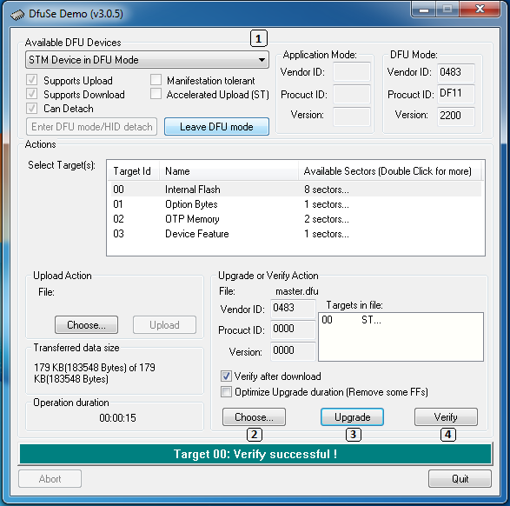
Snapshot of the DfuSe software

- Battery replacement
The battery provided is a li-polymer battery which is a common type found in majority of electronic equipment. The battery is connected to the mother board by a 2-pin connector. To replace, execute following steps:
    - Switch off the device and open the battery lid situated on the back of the device.
    - Remove the 4 screws on the edges of battery lid.
    - Remove the battery and unplug the connector.
    - Insert the new battery and plug in the connector. The connector is designed to connect only one way and easily slides in so do not force insert the connector.

- Specifications

Specification | Braille Me
Braille Display | Six-dot 20 Braille cells with cursor routing keys
Keyboard Type | 6 key Perkins-style
Ports | Micro USB, SD card slot, DC jack
Interface | USB v2.0, Bluetooth smart v4.2, SD card upto 32GB
Language | Supports 40+ languages, Capacity to hold six languages per device
Supported File Formats | .TXT, .BRL and .BRF
Screen readers | Android: BrailleBack 0.95.1 +  iOS 11+: Voiceover (under development)  MacOS High Sierra+: Voiceover (under development)  Windows 7+ : NVDA 2017.2+
Battery | 10 hours, 1.5 hours to charge(AC adapter)
Electrical parameters | Charging: 19V/1A  Charger AC socket: AC 100-240V, 50-60Hz, 1.0A
Size & Weight | 18.8 cm x 13.8 cm x 2.9 cm (W x D x H), 580g
Certification | CE certified  FCC and IC under process  FCC ID: A8TBM78ABCDEFGH  IC ID: 12246A-BM78SPPS5M2
Warranty | One-year limited parts and labor warranty

- Installing NVDA Add-on and driver

- Execute the NVDA screen reader

- On Braille Me Navigate to Menu -> USB Connection -> Connect to NVDA. Press enter key and Braille me should respond with the message “waiting for connection".

- If your Windows OS version is Windows 7 then you need to first install the Braille Me driver which is an executable file with the name “BrailleMeUsbDriver-64bit.exe”. If it is Windows 8 or 10 then you do not require to install the driver.

- You can check whether the driver is properly installed by going to device manager and checking if Braille Me is listed under USB peripherals. Note, if the Braille Me is not connected via USB and you have not entered the Connect to NVDA option on Braille Me, it will not show up in this list.

- Now on your PC execute the application with the name “brailleme-v0.5.nvda-addon” to install the Add-on for Braille Me in NVDA. As soon as the add-on installation is complete you are ready for connecting with NVDA.

- Now go to NVDA settings -> Preferences -> Braille Settings

- In the Braille Settings window Select the braille display as " Braille Me" and click on OK button.

- FAQs

  - Prospective User

- What is the weight and size of Braille Me?
Braille Me weighs just 580 g and its dimensions are 18.8cm x 13.8cm x 2.9cm.
- What are the contents of the box when I first receive my Braille Me?
The package contains the Braille Me device, a printed user guide, a braille user guide, Standard-A to Micro-B USB Cable, AC Charger and an 32GB SD card pre-inserted into the device.
- How fast is the braille refresh rate?
The refresh rate for the device stands at 300 milliseconds, which is just as quick as the time required by the human eye for a blink.
- How much sound does it make while typing and refreshing braille?
The sound generated while typing is pretty much similar to any computer keyboard. Refreshing the braille itself hardly makes a soft noise and can easily be used in a classroom environment.
- What are the features of the stand-alone mode?
In this mode, the device displays the content of files stored on an SD card. You can access previously created files from the SD card or create new files and save them for further use.
- What is the maximum size of SD card supported? What file formats are supported?
The device supports a card with a maximum storage of 32GB in an FAT-32 file system only. File formats supported by Braille Me are “.TXT” .BRL and “.BRF” encoded in ‘ANSI (ASCII)’.
- Does it support text to braille conversion?
Yes, It supports both grade 1 and grade 2 braille translation.
- How is Braille Me so low cost as compared to other braille displays?
Most other braille displays use piezo-electric technology for their braille cells, which is an expensive approach. Innovision has developed and patented a unique magnetic framework which reduces cost immensely while keeping the functionality intact. Also, cost optimization has been implemented at every stage from manufacturing to distribution to cater to a larger customer segment.
- Does it have audio input or output text to speech?
No, audio and speech recognition hasn’t been incorporated into the device. Braille Me is specifically designed to cater to a person’s braille requirements.
- With which screen readers does the device work?
We have provided support for NVDA for Windows, BrailleBack for Android and Voiceover (currently in development) for MacOS and iOS.
- How many bluetooth devices can be paired with Braille Me?
Braille Me supports a maximum of four paired devices at a time. Four devices of the BrailleBack and for Voiceover are separate.

  - First time user

- What is the proper orientation of the device?
Place the device on a flat surface in front of you with the row of braille cells farther away from you and the sloping edge nearer to you. This is the proper operational orientation.
- Why is the device 6 dot and not 8 dot? How do you show cursor in 6 dot?
The pressing dilemma at hand was whether to go for an 8 dot system for its utility or a 6 dot device for its cost efficacy. Therefore, we came up with a solution to integrate the cursor in the 6 dot module, thus, keeping the device operational and efficient at a lower cost while also being more accessible to the public.
There are two modes of displaying the cursor: In the first mode, the cursor blinks on the display, with the pins of the character being highlighted upright while the rest of the pins in periodic up and down motion. In the second mode, the manually triggered mode that is, the user has to press the Up + Down navigation keys simultaneously which results in a blank screen with only the cell accommodating the cursor to show up. Press the same combination keys again to revert changes. Refer to the manual for more details.
- How long does the product work on batteries before it needs a recharge?
The product takes about 1.5 hours to charge completely and following that, it can be used continuously for 10-12 hours before another recharge.
- How do I pair a device via Bluetooth?
First go to ‘Bluetooth’ option under menu. Select BrailleBack or Voiceover option as per your requirement. then go to ‘pair a new device’ option. As you enter this menu item Braille Me will show a message – ‘waiting for pair request’. Initiate pairing from the smartphone. Your smartphone might ask to confirm the pairing, please go ahead and press OK.
Wait for a few seconds until Braille Me changes its message from “waiting for pair request” to an edit box asking “Enter paired device name.” Enter a short name which you can use to identify your smartphone.
Once you receive a notification on Braille Me saying – “Paired to device name,” the pairing process is complete.
- Where can I find the product demonstration videos?
To view the demo videos, follow this URL link:
https://www.youtube.com/channel/UCmkFbfTI7MKUS2PjjfX4ppg/videos
- Where can I find Braille books online?
1. Sugamya Pustakalaya
https://library.daisyindia.org/NALP/welcomeLink.action
2. NLS
https://www.loc.gov/nls/
3. Bookshare Braille Central
https://www.bookshare.org/cms/help-center/training-and-resources/braille
- Can I use my Kindle app on my Android smartphone?
Make sure your BrailleBack or Voiceover is running in the background. now on the Amazon Kindle app, browse for the book you are looking for. You can either pay for a subscription or read any of the free books available. Once a certain page is open, the screen reader reads the contents of the page and reproduces it on the Braille Me display.
- How do I clean the braille display if needed?
Brushing away the display is a good option. Might also use a soft piece of cloth and press gently. Strictly avoid using water/Colin and other related wet media for cleaning purposes.

  - Existing User

- What are the warranty plans for the product and/or any of its accessories?
We provide a 1 year limited warranty for all accessories including the Braille Me unit itself.
- My Braille Me has trouble pairing with my mobile device?
One of the various possible issues may be that there are already 4 active devices paired to your Braille Me or you are trying to pair a device with a name that had already been reserved for some other device. To rectify the situation, you can delete a paired device from your Braille Me to accommodate the new device and try a different name for the former and latter situations respectively. For other issues refer to the user manual or contact customer support.
- My computer doesn’t recognize Braille Me as mass media storage?
This may be due to the fact that the user hasn’t followed the proper procedure to connect the device with the desktop. As long as ‘connected as a mass device’ is not shown on the display, the device will not connect to the desktop. If even after the message is displayed, there is trouble over connection, try unplugging the USB cable and re-plugging it. If the problem persists, contact customer support.
- One of my typing keys has stuck / There’s a problem with one or more pins in the display panel?
If a key is jammed, an error message is displayed on the screen indicating the user about the issue. You can try prying free the key but do not try too hard. If any of the dots are stuck try cleaning it using a soft brush or cloth. If the issue persists then contact customer support.

- Appendices

  - Warranty information
Inceptor Technologies Pvt. Ltd's (Innovision’s) warranty obligations for the Braille Me are limited to the terms set forth below:
Inceptor Technologies Pvt. Ltd. is referred as INNOVISION henceforth.
INNOVISION warrants that the Braille Me will be free from defects in materials and workmanship for a period of one (1) year from the date of shipment. If the product proves defective during the warranty period, INNOVISION, at its option, will:
- repair the product by means of telephone support or depot service at no charge for parts or labor,
- replace the product with a comparable product which may be new or refurbished

INNOVISION recommends the Customer first utilize support materials shipped with the product, product diagnostics, information contained on the Web, and email support. If unsuccessful, to obtain service under this warranty the Customer must notify INNOVISION or its authorized service representative of the defect before the expiration of the warranty period. Customers will provide appropriate assistance to Telephone Support personnel to resolve issues. If telephone support is unsuccessful, INNOVISION or its authorized service representative will instruct the customer on how to receive warranty repair.
A description of the repair process may be obtained from the authorized INNOVISION reseller/distributor. Repair service is at INNOVISION or its authorized service representative’s sole discretion and is considered an option of last resort. If the Customer’s product contains features that enable INNOVISION or its authorized service representative to diagnose and repair problems with the product remotely, INNOVISION may request that the Customer allow such remote access to the product. In the maintenance of the product, INNOVISION may use new or equivalent to new parts, assemblies or products for equal or improved quality. All defective parts, assemblies, and products become the property of INNOVISION. INNOVISION may require the return of parts, assemblies and products to a designated INNOVISION representative from which the part, assembly, or product was originally purchased. Return and claims will be handled according to the current INNOVISION procedure. These warranties shall not apply to any defect, failure or damage caused by improper use or improper or inadequate maintenance and care. INNOVISION shall not be obligated under these warranties:
a) to repair damage resulting from attempts by personnel other than INNOVISION representatives/ authorized INNOVISION reseller/distributor to install, repair or service the product unless directed by a INNOVISION representative,
b) to repair damage, malfunction, or degradation of performance resulting from improper use or connection to incompatible equipment,
c) to repair damage, malfunction, or degradation of performance resulting from failure to properly prepare and transport the product
d) to provide software or firmware updates or upgrades.
Any service identified in the above list and provided by INNOVISION at the Customer’s request shall be invoiced to Customer at INNOVISION’s then current rates for parts, labor and travel. THE ABOVE WARRANTIES ARE GIVEN BY INNOVISION WITH RESPECT TO THIS PRODUCT AND ITS RELATED ITEMS IN LIEU OF ANY OTHER WARRANTIES, EXPRESS OR IMPLIED. INNOVISION AND ITS VENDORS DISCLAIM ANY IMPLIED WARRANTIES OF MERCHANTABILITY OR FITNESS FOR A PARTICULAR PURPOSE OR ANY SIMILAR STANDARD IMPOSED BY APPLICABLE LEGISLATION. INNOVISION'S RESPONSIBILITY TO REPAIR OR REPLACE FOR DEFECTIVE PRODUCTS AND RELATED ITEMS IS THE SOLE AND EXCLUSIVE REMEDY PROVIDED TO THE CUSTOMER FOR BREACH OF THESE WARRANTIES. Some states, provinces, and countries do not allow the exclusion or limitation of incidental or consequential damages or exclusions or limitations on the duration of implied warranties or conditions, so the above limitations or exclusions may not apply to you. This warranty gives you specific legal rights, and you may also have other rights that vary by state, province, or country. TO THE EXTENT ALLOWED BY LOCAL LAW, EXCEPT FOR THE OBLIGATIONS SPECIFICALLY SET FORTH IN THIS WARRANTY STATEMENT, IN NO EVENT SHALL INNOVISION AND ITS VENDORS BE LIABLE FOR ANY INDIRECT, SPECIAL, INCIDENTAL OR CONSEQUENTIAL DAMAGES (INCLUDING LOSS OF PROFITS) WHETHER BASED ON CONTRACT, TORT, OR ANY OTHER LEGAL THEORY AND IRRESPECTIVE OF WHETHER INNOVISION OR THE VENDOR HAS ADVANCE NOTICE OF THE POSSIBILITY OF SUCH DAMAGES.
Inceptor Technologies Pvt. Ltd. (INNOVISION)
CM09, SINE
3rd floor CSRE bldg., IIT Bombay
Powai, Mumbai, India.
Phone: +91 – 829-140-6811
E-mail: customercare@Innovisiontech.co
Web: www.Innovisiontech.co

