1
The catalog of products for the visually impaired and hard of hearing
1-800-468-4789 (Toll Free, Monday – Friday 9am-5pm Eastern Time)

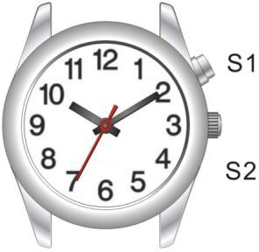

101103 Braille Talking Watch: Setting Instructions Setting sleep mode;
Hold S1 for 5 seconds to activate the watch from sleep mode. Hold S1 for 5 seconds to enter sleep mode.

To set current time, pull out the crown and set hour and minute hands to desired time. Then push back the crown to normal position.

When you check the time, you also can touch the watch hands lightly to get it. (do not push the watch hands.)

Time and Date Announcement Press S1 once, to hear time Press S1 twice, to hear date

Setting functions:
Set hour
Press S2 to set hour, then press S1 to adjust to the hour.

Set minute
Press S2 to set minute, then press S1 to adjust to the minute.

Set year
Press S2 to set year, then press S1 to adjust to the year.

Set month
Press S2 to set month, then press S1 to adjust to the month.

Set date
Press S2 to set date, then press S1 to adjust to the date.

Set Alarm hour
Press S2 to set alarm hour, hen press S1 to adjust to the hour.

Set Alarm minute
Press S2 to set alarm minute, then press S1 to adjust to the minute.

Set Alarm
Press S2 to set alarm, then press S1 to adjust alarm on / alarm off

In setting mode, don’t push any buttons for 5 seconds, it will return to normal time mode.

